Experiment No.4

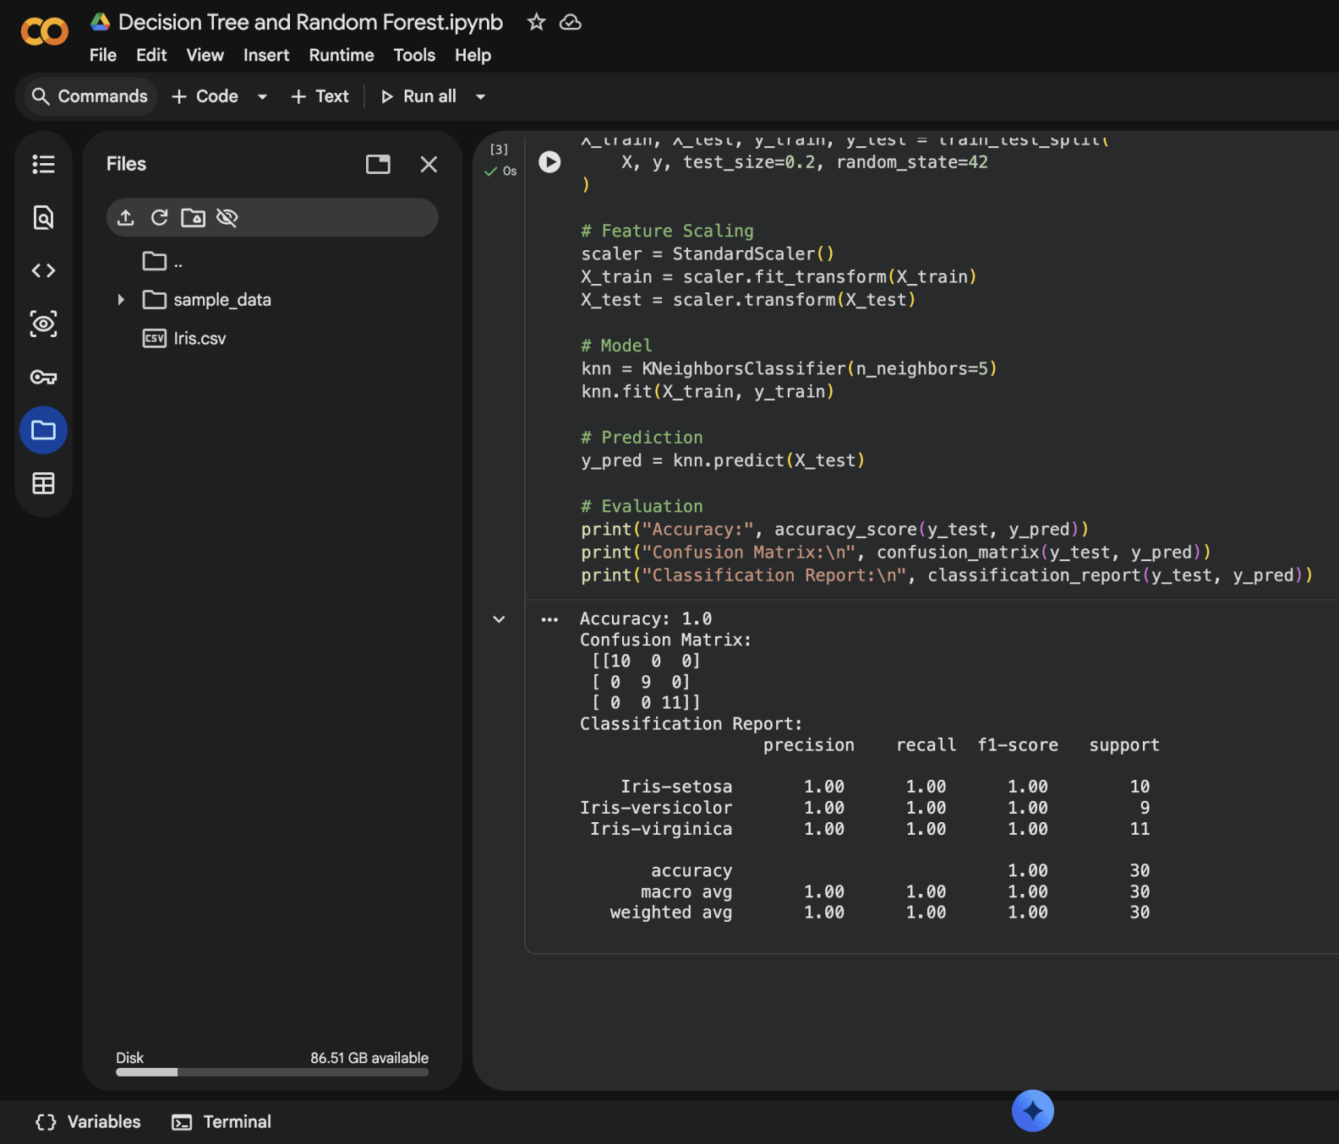

Dataset Source
Dataset Name: Iris Flower Dataset
Source (Kaggle):https://www.kaggle.com/datasets/uciml/iris

Dataset Description
The Iris dataset is used for multi-class classification.
Total Samples: 150
Features: 4 numerical features
Target Classes: 3 species

Features:
Feature | Description
sepal_length | Length of sepal (cm)
sepal_width | Width of sepal (cm)
petal_length | Length of petal (cm)
petal_width | Width of petal (cm)

Target Variable.
- 0 → Setosa
- 1 → Versicolor
- 2 → Virginica
Type: Supervised Multi-class Classification

Mathematical Formulation of KNN
KNN is a non-parametric, distance-based algorithm.

Distance Calculation (Euclidean Distance):
d(x, x_i) = \sqrt{\sum_{j=1}^{n}(x_j - x_{ij})^2}
Where:
- x = test sample
- x_i = training sample
- n = number of features

Classification Rule:
- Choose value of K
- Compute distance from test point to all training points
- Select K nearest neighbors
- Assign majority class

Algorithm Limitations
- Slow for large datasets (computes distance every time)
- Sensitive to value of K
- Affected by irrelevant features
- Requires feature scaling
- Performs poorly in high-dimensional data (Curse of Dimensionality)

Methodology / Workflow
Dataset → Data Cleaning → Feature Scaling → Train/Test Split →
Model Training → Prediction → Performance Evaluation

Steps:
- Load dataset
- Scale features (StandardScaler)
- Split data
- Train KNN model
- Predict results
- Evaluate performance

Python Implementation
import pandas as pd
import numpy as np
from sklearn.model_selection import train_test_split
from sklearn.preprocessing import StandardScaler
from sklearn.neighbors import KNeighborsClassifier
from sklearn.metrics import accuracy_score, confusion_matrix, classification_report

# Load dataset
df = pd.read_csv("Iris.csv") # Download from Kaggle

# Drop ID column if exists
if "Id" in df.columns:
df = df.drop("Id", axis=1)

X = df.drop("Species", axis=1)
y = df["Species"]

# Train-Test Split
X_train, X_test, y_train, y_test = train_test_split(
X, y, test_size=0.2, random_state=42
)

# Feature Scaling
scaler = StandardScaler()
X_train = scaler.fit_transform(X_train)
X_test = scaler.transform(X_test)

# Model
knn = KNeighborsClassifier(n_neighbors=5)
knn.fit(X_train, y_train)

# Prediction
y_pred = knn.predict(X_test)

# Evaluation
print("Accuracy:", accuracy_score(y_test, y_pred))
print("Confusion Matrix:\n", confusion_matrix(y_test, y_pred))
print("Classification Report:\n", classification_report(y_test, y_pred))

Performance Evaluation

Metrics Used:
- Accuracy
- Confusion Matrix
- Precision
- Recall
- F1-score

Interpretation:
- Accuracy close to 1 → strong classification performance
- Confusion matrix shows correct vs incorrect predictions
- F1-score balances precision and recall
Typical Result on Iris:
- Accuracy ≈ 95% – 100%

Hyperparameter Tuning

Important Hyperparameters:
- n_neighbors (K)
- metric (euclidean, manhattan)
- weights (uniform, distance)

GridSearch Example:
from sklearn.model_selection import GridSearchCV

param_grid = {
'n_neighbors': range(1, 15),
'weights': ['uniform', 'distance'],
'metric': ['euclidean', 'manhattan']
}

grid = GridSearchCV(KNeighborsClassifier(), param_grid, cv=5)
grid.fit(X_train, y_train)

print("Best Parameters:", grid.best_params_)
print("Best Accuracy:", grid.best_score_)

Impact:
- Choosing optimal K improves accuracy
- Prevents underfitting (low K) and overfitting (high K)

Final Conclusion
- KNN is simple and effective for small datasets.
- Works very well on structured, well-separated data like Iris.
- Requires scaling and proper K selection.
- Not ideal for very large datasets due to computational cost.

